This wiki page contains some of the best practice to be followed when working with Power BI. These are grouped under different categories.

Data Integration and Power Query

Data Connections
There are three different data source connection types. In the majority of the cases the connection type Import will be fine, and sometimes Direct Lake might also be applicable. Direct Query connections should normally be avoided.
  - Import
  - Direct Query
  - Direct Lake

Import mode
  - Remove the unnecessary rows and columns from source data.
  - Use views as source of data. Because any changes to the underlying tables will
  - not have impact on the existing report.
  - Make sure the data types are optimized.
  - Splitting DateTime columns in two columns one for Date and one for time will give better model performance. Model would be easier to use.

Direct lake connection type
Direct lake is preferable over import in the following two scenarios (as a viable replacement to direct query connection type reports)
  - Real time data refresh important
  - Super large data models having a big “cost impact” or models which are only refreshable via incremental refresh / partitions.

Disadvantages Direct Lake:
- Setup slightly more complex
- Not all datasources supported
- “Auxiliary tables” can only be added via lakehouse+shortcut to PBI warehouse.
- Calculated tables and calculated columns not possible.
- Field parameters only possible via Tabular Editor. And not as easy to implement there.
- Designing data models in Power BI Desktop is currently in preview with lots of limitations. Instead PBI Service needs to be used: https://learn.microsoft.com/en-us/fabric/get-started/direct-lake-power-bi-desktop#considerations-and-limitations
- There is a long list of further considerations/limtations at least currently with direct lake: https://learn.microsoft.com/en-us/fabric/get-started/direct-lake-overview#considerations-and-limitations

Other Best Practices
- Minimize Power Query transformations - Minimize Power Query transformations to improve model processing performance. It is a best practice to offload these transformations to the data warehouse if possible. Also, please check whether query folding is occurring within your model.
- Split date and time - This rule finds datetime columns that have values not at midnight. To maximize performance, the time element should be split from date element (or the time component should be rounded to midnight as this will reduce column cardinality).
- Reduce usage of long-length columns with high cardinality - It is best to avoid lengthy text columns. This is especially true if the column has many unique values. These types of columns can cause longer processing times, bloated model sizes, as well as slower user queries. Long length is defined as more than 100 characters.
- Reduce Data Volume - Avoid loading rows or columns of data that are not necessary to answer the specific questions that are the purpose of your report.
- Remove redundant columns in related tables - If only one is needed, delete the others from the model.
- Remove unused sources – Remove unused sources which are not being used or referenced in report.

Data Modeling

General Data Modeling
Mandatory:
- Separate Report and Semantic Model if more than one report use the model as source - see Appendix 2 for details
- Calendar Table:
  - Model should have a date table - Models should generally have at least a date table. Models that do not have a date table are not taking advantage of features such as time intelligence or may not have a properly structured architecture.
  - Date/calendar tables should be marked as a date table - This rule looks for tables that contain the words 'date' or 'calendar' as they should likely be marked as a date table.
  - Disable Auto-Date/Time - Avoid using auto-date tables. Make sure to turn off auto-date table in the settings in Power BI Desktop. Additionally remove automatically created date tables when you see them. This will save memory resources.
- Create Explicit Measures

Recommended:
- Avoid Calculated Columns and Power Query Transformation as this should be done in Backend
  - Reduce number of calculated columns - Calculated columns do not compress as well as data columns, so they take up more memory. They also slow down processing times for both the table as well as process recalculation. Offload calculated column logic to your data warehouse and turn these calculated columns into data columns.
  - Reduce usage of calculated tables - Migrate calculated table logic to your data warehouse. Reliance on calculated tables will lead to technical debt and potential misalignments if you have multiple models on your platform.
- Remove unnecessary columns - Hidden columns that are not referenced by any DAX expressions, relationships, hierarchy levels or Sort By-properties should be removed.
- Remove unnecessary measures - Hidden measures that are not referenced by any DAX expressions should be removed for maintainability.
- “Star Schema All The Things”
  - Consider a star-schema instead of a snowflake architecture when it's possible - A star-schema is the optimal architecture for tabular models. Please check your model and consider moving to a star-schema architecture. Flat tables should be avoided as well.
  - KPIs should be in columns and not in rows - Unlike other BI tools Power BI performs best when the KPIs are in separate columns and not in rows.
  - Galaxy schema instead of single star schema - Having multiple stars in your model is preferred over one big star schema. This allows for different granularity if needed and performance wise also optimal
- Relationships:
  - Prioritizing “one to many” relations - To boost the performance of the dashboard, it is advised to use “one to many” relations over the “many to many” relations. Sometimes it is reliable to create bridge tables to avoid “many to many” relations.
  - Many to Many - Many-to-many relationships should be made in single direction.
  - Check if bi-directional and many-to-many relationships are valid - Bi-directional and many-to-many relationships may cause performance degradation or even have unintended consequences. Make sure to check these specific relationships to ensure they are working as designed and are necessary.
- Use a central template repository in combination with TMDL View for
  - Calendar table
  - Calculation groups
    - Time intelligence calc group
    - Units calc group
  - Parameter
  - Footer:
    - Last Refresh Timestamp
    - Adding Datasource Parameter Table and Measure
  - Adding description to all measures with TMDL View
  - Adding detailrowsexpresions to all Displayfolders (group of measures) with TMDL View
Example for Star Schema :
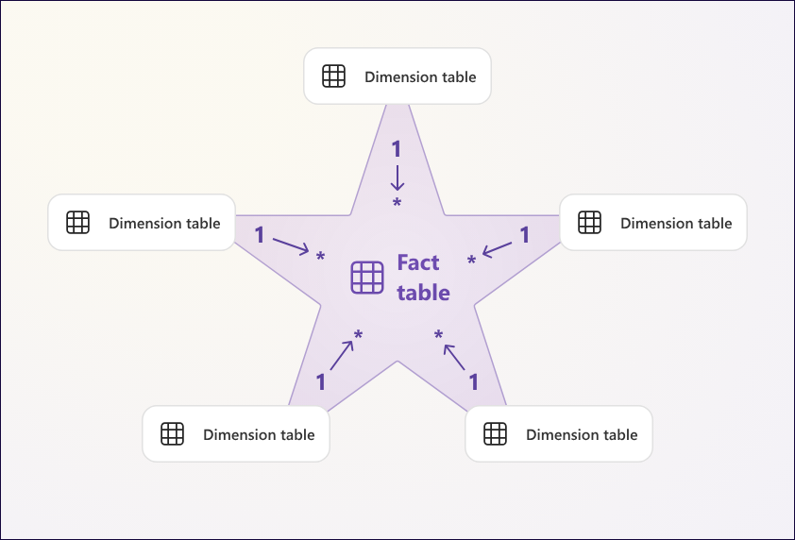

DAX – Data Analysis Expressions
DAX is a collection of functions, operators, and constants that can be used in a formula, or expression, to calculate and return one or more values in Power BI. The following are the rules that should be followed when building DAX expressions.
Mandatory:
- Use the DIVIDE function for division - Use the DIVIDE function instead of using the operator "/". The DIVIDE function resolves divide-by-zero cases. As such, it is recommended to use to avoid errors involving that.
Recommended:
- Use DAX variable if possible - If possible, use the function VAR inside a DAX expression when it is needed to make references inside a function.
- Use SWITCH instead of nested IF statements - Switch function is more efficient than If Else. Use of the nested IF increments the process to the engine, therefore it should be avoided when possible. Use the function SWITCH(TRUE(),{}) instead.
- Avoid using the IFERROR function - Avoid using the IFERROR function as it may cause performance degradation. If you are concerned about a divide-by-zero error, use the DIVIDE function as it naturally resolves such errors as blank (or you can customize what should be shown in case of such an error).
- Use the TREATAS function instead of INTERSECT for virtual relationships - The TREATAS function is more efficient and provides better performance than the INTERSECT function when used in virtual relationships.
- Reduce usage of calculated columns that use the RELATED function - Calculated columns do not compress as well as data columns and may cause longer processing times. As such, calculated columns should be avoided if possible. One scenario where they may be easier to avoid is if they use the RELATED function.

Organization of Measures
Mandatory:
- Use Measure Tables as Container. Use Name “Measure” (not “Measures”)
  - A “Measure Table” as container for your measures is theoretically not needed if all columns in the fact table are hidden (fact table is fully denormalized)
  - But in all other cases we strongly recommend to create a measure table where you store the measures in. During the development phase this can be additional beneficial.
  - Measure Tables have the following benefits:
    - Easily locate measures. Shown on top and name is always the same
    - Measures from Multiple Fact tables can be grouped together (e.g. clear where to find the actual vs plan measures from different fact tables are located)
Recommended:
- Use Display Folders
  - Use Folders and sub folders to group the measures and other fields.
  - Have a meaningful names to folders and subfolders.
  - To create new folders, go to the Model by selecting it in the left panel, and select the measure that you want to allocate in the folder. In Properties > Display Folder, write the desire name. Whenever you write the same name for other measures, they will be saved in the same folder.

Extended Properties of Columns
Mandatory
- Hide foreign keys - Foreign keys should always be hidden.

Recommended:
- Hide fact table columns - It is a best practice to hide fact table columns that are used for aggregation in measures.
- Mark primary keys - Set the 'Key' property to 'True' for primary key columns within the column properties.
- Format flag columns as Yes/No value strings - Flags must be properly formatted as Yes/No as this is easier to read than using 0/1 integer values.

Naming Conventions
Mandatory:
- Naming Conventions: Everything Clean “Title Case” & No Table Prefix like “Fact” or “Dim”
- Objects should not start or end with a space – Make sure there are no leading or trailing white spaces for the names of any objects
- Special characters - Object names must not contain special characters
- Column references should be fully qualified - Using fully qualified column references makes it easier to distinguish between column and measure references and helps to avoid certain errors. When referencing a column in DAX, first specify the table name, then specify the column name in square brackets. E.g. TableName[Column Name].
- Measure references should be unqualified - Using unqualified measure references makes it easier to distinguish between column and measure references and helps to avoid certain errors. When referencing a measure using DAX, do not specify the table name. Use only the measure name in square brackets. E.g. [Measure Name]..
- Provide Tables, columns and measures a descriptive business names without overly short abbreviations.

Recommended:
- Use the similar name for related measures - When a measure calculates some KPI, use similar names for the variations of the measure (i.e., Target Frequency, Target Coverage, …).
  - AC, PY, PM, PL, YTD, MTD, ΔPY, ΔPY %, ΔPL, ΔPL %
  - avg. (avoid in international context “Ø”)
  - mio, k (avoid in German context „billion“)

Report Design

General Recommendation
Mandatory:
- Use a standard report template and design theme with backed-in background. Don’t create the background within Power BI with shapes and individual elements

Recommended:
- Use the 3 line title concept top left of every page à Make it with “SELECTEDVALUE” dynamic if possible
  - Company + Division
  - KPIs in bold with units and currency
  - Time Period
- Use Filter Pane instead of Report Slicers
  - Exception for the use of slicers are if those are critical to show the correct information. In such cases those field parameters should behave like a title of the visual or should be tightly integrated. E.g. field parameters used in a transparent slicer over cards
  - Use slicers sparingly - Adding too many slicers drastically slows performance.
- Use “In Report” Navigation instead of built-in Navigation
- 3 – Layer Concept - Structure your report in two better three layers:
  - Overview: All KPIs of report as either tiles/cards (Netflix principle) or better one big table with percentage deviations to targets
  - Analysis: individual KPI (group) with visualization
  - Details in form of tables or small multiples.
- Avoid Power BI bookmarks for report functionality instead
  - Use page navigation
  - Use field parameters for KPIs / Attributes
- Use Cross Filtering instead of Cross Highlighting
- 1080x1920: Use instead of the default 16:9 page size, custom 1080x1920 property. The aspect ratio stays the same, just the number of pixels is increased
  - No disadvantage: The report can look almost identically if you wish. The default design theme is having bigger font size to adjust for this change.
  - Only advantages: The only difference is that if you wish the visuals can be made a bit smaller with smaller font sizes and bars. Therefore if you need it, a higher information density without loosing clarity is possible
- Use tooltips to provide more information on visuals and metrics - Report tooltips are a great way of sharing additional information in a limited report space. The use of customized tooltips is a great way to increase information density, but if you do so, consider to
- Avoid scrolling pages - As much as possible try to avoid scrolls within the visual and on page. Instead use a navigation concept with multiple pages and for visual scrolls consider consolidating smaller segments in “Others”.
- Test custom visual performance before use - Uncertified custom visuals are generally not tested by the Power BI team. Therefore, whenever one is used, its functionality should be tested properly both in Power BI Desktop and in the cloud version, to avoid issues when uploading dashboards.
- Remove unnecessary interactions between visuals - Disabling unnecessary interactions, you reduce the number of queries fired at the back end, which improves report performance.

Report Visualization – Pattern Recognition to Increase Efficiency and Effectiveness of Reports
Mandatory:
- Orientation of Charts
  - Structure – Horizontal Charts
    - Horizontal Bar charts (not column charts) with multi tiers
    - Tables
  - Time – Vertical Charts
    - Vertical column charts (with in-line variances)
    - Line Charts
- Focus on Deviations to any or multiple of the following: plan, previous time period, forecast

Recommended:
- Patterns of bars:
  - Filled color: Actual values = AC
  - Lighter filled color: Previous Year values = PY
  - Outlined bar: Plan values = PL
- Avoid visualization options with low information density: Especially pie chart and gauges but also various others Donut Chart, Treemap, Mekko, bullet charts, maps with area filling (if map is really needed than use “proportional pie charts” on the map instead)
- Use “New card”
  - instead of many individual old cards, have just one visual
  - Avoid “Big Numbers” add reference labels, better sparklines
- Colors should mean something
  - Use color with a purposeful
  - Reserve Red and Green for deviations: positive and negative impact (e.g. increased cost compared to previous year is green)

Other

Maintenance
- Power BI Desktop Update - Work with latest version of Power BI Desktop to avoid discrepancies with the live version or colleagues’ collaborations.
- Fix referential integrity violations - This rule highlights relationships which have referential integrity violations. This indicates that there are values in the table on the 'from' side of the relationship which do not exist in the table on the 'to' side of the relationship. Referential integrity violations will also produce the 'blank' member value in slicers. It is recommended to fix these issues by ensuring that the 'to' table's primary key column has all the values in the 'from' table's foreign key column.
- Use on-premises data gateway instead of Personal Gateway - Personal Gateway imports data into Power BI. On-premises data gateway (also known as Enterprise Gateway) imports nothing, which is more efficient when working with large databases. Besides, with the enterprise Gateway, the report will be able to be updated by more people. NOTE: This is applicable if source is on-premises.

Performance
- Consider using aggregations if using Direct Query in Power BI - If using Direct Query in Power BI Premium, you may want to consider using aggregations to boost performance.
- Check if dynamic row level security (RLS) is necessary - Usage of dynamic row level security (RLS) can add memory and performance overhead. Please research the pros/cons of using it.

Links for further Learning
Below are useful links which would provide more detailed Learning/Infomation on the best practices:
https://learn.microsoft.com/en-us/power-bi/guidance/
https://learn.microsoft.com/en-us/power-bi/create-reports/service-dashboards-design-tips
https://radacad.com/power-bi-development-best-practices
https://learn.microsoft.com/en-us/power-bi/guidance/directquery-model-guidance

Appendix 1 Tabular Data Modeling - Naming Conventions
Numerous programming languages utilize style guides to help developers create content that is both consistent and easy to read. Similarly, it's essential to apply such principles to Tabular modeling. Often, models are designed with a back-end engineering approach, yet they are actually deployed in front-end applications. Business users interact with Tables, Columns, Measures, Hierarchies, and KPIs, making it crucial to tailor the naming and formatting of models to suit their needs.

As the platform expands to accommodate more users and data models, adhering to a Tabular Style Guide becomes increasingly critical. This guide not only enhances the aesthetic experience for users but also ensures consistency across different models, making it easier for users to switch between them. The idea is to make using any model on the platform as straightforward as learning to ride a bike - once you've mastered one, you can easily adapt to others.

The guide is organized into various components of a tabular model, such as Tables, Partitions, Columns, Measures, Hierarchies, Relationships, Data Sources, Perspectives, Roles, and Display Folders, with the first section focusing on general rules applicable to all model objects.

Additionally, the Tabular Editor's Best Practice Analyzer can be used to automate and validate many of these rules, streamlining the process and allowing you to concentrate on more strategic aspects of your platform.

The Rules below are a template and can be changed if different naming conventions are desired, however this is our recommendation based on best practices.

General Rules
  - Words in visible objects must always be separated by spaces.
  - Title Case is mandatory for all visible objects.
  - Prohibited characters: [ ] { } ' " = & * : ; . / \ # @ ! _ = ^.
  - Restricted words include:
    - Reserved words like Table, Measure, Column, KPI (except 'Hierarchy' in hierarchies).
    - 'Total' to avoid redundancy in totals.
    - 'Is' to promote clarity in column names.
    - 'Amount', 'Value' for being often redundant.
    - 'Name' unless necessary, like in 'Customer Name'.

Tables
  - Avoid using 'Hierarchy' in table names.
  - Specific guidelines for Calendar Dimension:
    - It must be marked as a date table.
    - Primary key (DateId) should be INTEGER in YYYYMMDD format.
    - Date and time must be split, with Calendar granularity at 'Day' and Time more granular.
  - Naming conventions for different table types:
    - Fact table (e.g., Revenue in model, FACT_Revenue in database).
    - Dimension table (e.g., Geography in model, DIM_Geography in database).
    - Bridge table (e.g., GeographyBridge in model, BRIDGE_Geography in database).
    - Security table (e.g., UserGeography in model, SEC_UserGeography in database).
    - Metadata table (e.g., Data Dictionary in model, META_DataDictionary in database).
  - Note on the absence of spaces in GeographyBridge & UserGeography.
  - Hidden tables can also be completely be removed from the semantic model with the “private” property in Tabular Editor. This should not be used to secure your tables in the model. Intellisense will not work for those tables, but users could still write measures against it. Make sure to not use this property for hidden fact tables, but rather for bridge or user role tables. Hidden fact tables should not be private in order to allow better comprehension and allow for report specific measures to be created.

Partitions
  - Single-partitioned tables should have the same name for Partition and Table.
    - Use simple views for quick development and flexibility.
    - Views must have no logic, which should reside in stored procedures.
    - View schema should include the model name followed by 'View'.
  - Multi-partitioned tables must begin Partition Names with the Table Name.
    - Examples include Revenue FY19, Revenue FY19-Q1, Revenue FY19-M01, etc.
    - Partitioning should be done in the database layer for efficiency and query simplification.

Columns
  - Flags must be STRING datatype and use values like Yes, No, N/A, Unknown.
  - Primary keys should be INTEGER, end in 'ID', marked as Key, and generally hidden.
  - Foreign keys must also be INTEGER, end in 'ID', be hidden, and match primary key names.
  - Sort-by-columns require INTEGER datatype and should be hidden.
  - Aggregatable columns should be INTEGER, CURRENCY, or DECIMAL, hidden, and create a measure.
  - Non-aggregable integer columns should be marked as 'None' or 'Do Not Summarize'.
  - Columns in the database layer should not have spaces, which are added in the model.
  - Dimension table primary keys should align with fact table foreign keys, avoiding blanks.
  - Specify URLs as WebURL in column properties.

Measures
  - Formatting rules for Currency, Whole numbers, and Percentages.
  - Naming conventions:
    - Brief and descriptive.
    - Prefixes like Avg, product information.
    - Suffixes like PY, PQ, PM, YTD, TTM, VTB.
  - Measure references should not prefix with the table name.

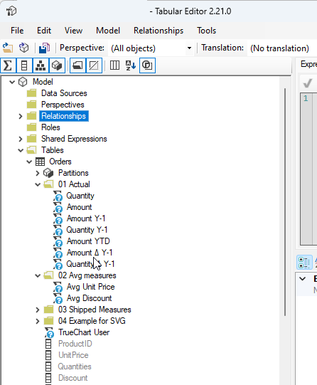

Hierarchies
  - Must end with 'Hierarchy'.
  - Attributes must match column names outside the hierarchy.
  - The order should reflect natural hierarchy levels.
  - This facilitates practical / easier working with external tools such as Tabular Editor

Relationships
  - Automatically named; no specific naming standards required.

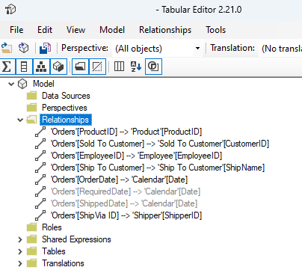

Data Sources
  - Name should include three components: Provider, Data Source, Initial Catalog.

Perspectives
  - Adhere to the General Rules with no additional specific standards.
  - Important note: This should not be used to secure parts of your semantic model. OLS or even better RLS should be used.

Roles
  - Ensure role members do not overlap between roles to prevent errors and unauthorized data viewing.

Display Folders
  - Used for grouping two or more measures/columns within the same table.
  - If using a multi-folder approach, it should align with user categorization methods.

Key Definitions for Measures
  - Define abbreviations like YoY (Year-over-Year), QoQ (Quarter-over-Quarter), MoM (Month-over-Month), YTD (Year-to-Date), QTD (Quarter-to-Date), MTD (Month-to-Date), PY (Previous Year), PQ (Previous Quarter), PM (Previous Month), TTM (Trailing 12 months), VTB (Variance-to-Budget), and VTF (Variance-to-Forecast).
  - Instead of PY for previous year a valid recommendation would also be to use Y-1 instead. This is especially important if the Y-2 is a relevant KPI for the business context in question.
  - For target or budget numbers “PL” is often the choice over BUD, since BU is not really an option as it could be used for Business Unit instead of Budget. And the three letter abbreviation BUD is also not optimal since PY is just 2 letters.

Appendix 2: Key Concept: separate Report and Data Model

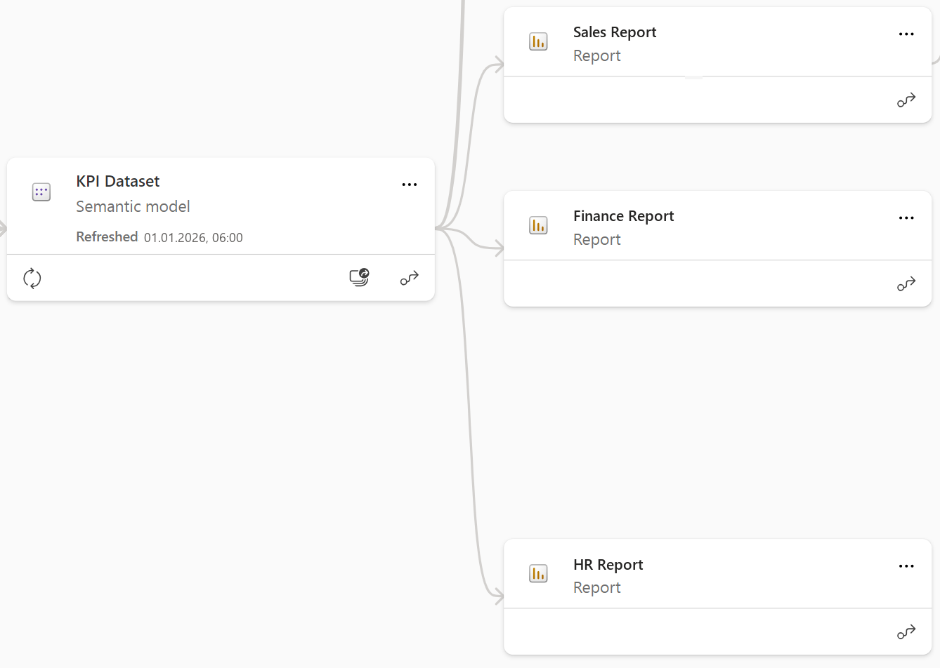

Reports can be separated from the data model in Power BI by utilizing the Live Connection feature which connects a report to a semantic model. The Lineage of a report can be viewed in Power BI Service by utilizing the Lineage View feature.

In the scope of Power BI report and data model development, the fundamental principle is the clear separation of the report creation and data model development.
This best practice is supported by the strategic use of the most suitable tools for each component.

For data model creation, Tabular Editor is the tool of choice, appreciated for its advanced functionalities and adaptability. It enables sophisticated model management, even in non-Premium environments, by connecting with an empty Power BI Desktop file.

On the other hand, Power BI Desktop is ideal for report building, thanks to its intuitive interface and powerful visualization options.

This approach not only simplifies the development process but also ensures that each part of the Power BI project is optimized with the best resources available, resulting in a more streamlined, efficient, and effective workflow. This method is especially beneficial in environments where separate teams handle model development and report creation, as it allows for simultaneous development on the same report, therefore optimizing the whole process.

Appendix 3: Power Query - Best Practices
In Power Query there are some important best practices to follow. The following list should be agreed on during the conceptual phase, but also checked back during development as well as in an assessment phase.

Best Practice | Description | Applied
Query Folding | For data sources with query folding it is ensured that breaking steps are either applied at the source and when this not possible are applied last. | Yes / No
Group queries | Queries are grouped together in a meaningful way, e.g. according to data source or layer or type (dim, fact) | Yes / No
Last Refresh Timestamp Added | All import models consist of at least one query for a timestamp of the data models last refresh. This last refresh query needs to be made sure to apply to different partitions or incremental refresh policies if exist. | Yes / No
Last Refresh Timestamp correct Time | Last Refresh Timestamp is in correct time according to summer/winter time and in local not UTC time. It is not sufficient to test this solely in Power BI Desktop, instead also needs to be tested in Power BI Service. | Yes / No
Integer Datekeys | Datekeys are in Integer for optimal performance. If needed for incremental refresh function to convert to datetime is used. | Yes / No
Documentation of Steps and Queries | At least the most important steps are documented. This can easily be done with support from AI and the advanced editor. The line above each Power Query transformation is the comment visible in Power Query. It is not only possible to comment steps but also queries as a whole. | Yes / No
Parameters for Connection Strings / Datasource | Parameters are used for all connection strings and data sources. This helps especially for instances, when the data source is a folder/file or if there is a dev and prod database / servername. The parameters are split and combined when possible: e.g. folder+filename. | Yes / No
Queries are referenced and not duplicated | When queries need to be used twice, those queries are “referenced” and not “duplicated”. If just a portion is used twice it makes sense to split this into a main not loaded and two depending queries. | Yes / No
Staging tables are Disabled Load | unnecessary staging tables are grouped correctly and the load is disabled | Yes / No
Grouping Modification Steps | The same steps are grouped together, so that the list of applied steps gets as short as possible. E.g. renaming is done if possible very last. | Yes / No
Naming Conventions | Naming conventions are applied as defined in the tabular style guide, if possible those naming conventions are pushed back to the data source and not applied within power query. | Yes / No
Working with Column Names | If possible it is avoided to work with column names. Since those steps could be breaking if the source columns names change. E.g. renaming a column should be done at the source either way. | Yes / No
Data Gateway | For online data sources try to avoid the on-premises data gateway. For example refrain from using Web.BrowserContents and replace it with the old Web.Contents connector. | Yes / No

